[Add Attachment]

Technical Document

Date: 10/Aug/2018

Version: Version 0.1

# Table of Contents

Table of Contents 1

[Add attachment] 2

Description 2

1.1 Mockup screen: 2

1.2 Angular & Spring Models 2

1.3 Angular Component 3

1.4 Rest Services 3

1.5 Flow Services: 4

1.6 Repository Functions 4

1.7 Database Script: 5

1.8 ER Diagram: 5

# 

# [Add Attachment]

Refer to: [Taiga URL]

## Description

Add Attachments (Upload) for Course and View Attachment

## Mockup screen:

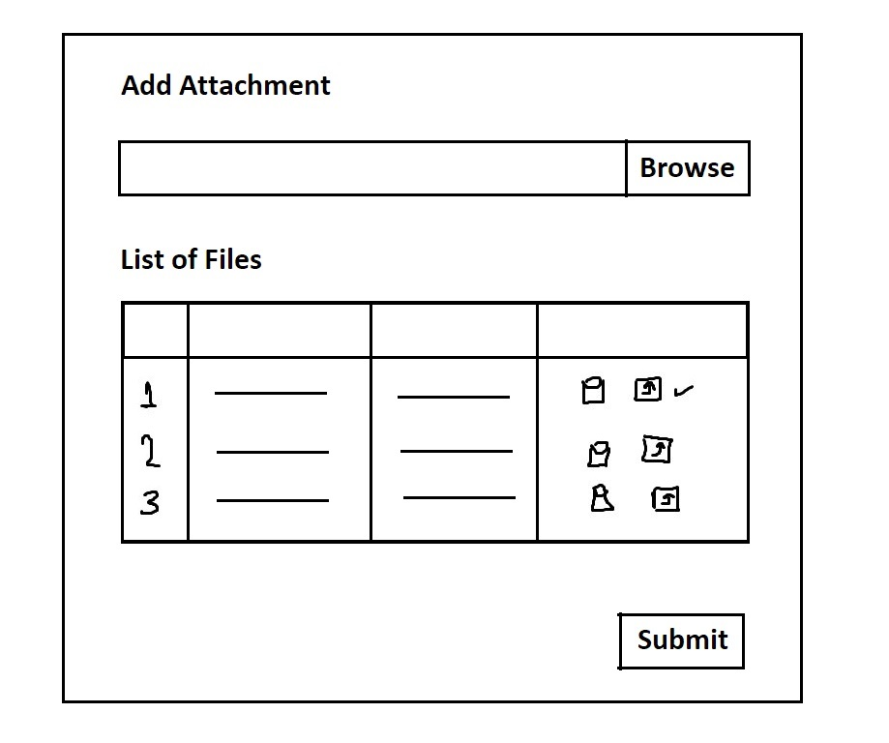

## Angular & Spring Models

|  |  |  |  |
| --- | --- | --- | --- |
| **New** | **Class Name** | File | |
| **Angular Path** | | app/infrastructure/components/manage-attachment/shared/data/file.data.ts | |
| **Spring Path** | | model/attachment/File.java | |
| **Fields** | | | |
| **Attribute** | | **Angular Data Type** | **Spring Data Type** |
| name | | string | String |
| type | | string | String |
| size | | number | double |
| extension | | string | String |
| source | | string | String |
| File_Source_id | | string | string |
| File_id | | --- | int |
| File_path | | --- | string |

## Angular Component

|  |  |  |
| --- | --- | --- |
| **New** | **Class Name** | upload |
| **Path** | | app/infrastructure/components/manage-attachment/components/upload.component.[ts/html] |

|  |  |  |
| --- | --- | --- |
| **New** | **Class Name** | download |
| **Path** | | app/infrastructure/components/manage-attachment/components/download.component.[ts/html] |

|  |  |  |
| --- | --- | --- |
| **New** | **Class Name** | Attachment.service |
| **Path** | | App/infrastructure/components/manage-attachment/shared/attachment.service.ts |
| **Function** | | UploadFile(file: File)  uploadMutlipleFiles(files:File[])  downloadFile(id:number)  removeFile(id : number) |

## Rest Services

|  |  |  |  |  |  |  |
| --- | --- | --- | --- | --- | --- | --- |
| **New** | **Name** | | api/file/uploadFile | | **Method** | POST |
| **Controller** | | | FilesRes | | **Function** | uploadFile(file) |
| **REST Parameter** | | | | | | |
| **Attribute** | | **Parameter Type** | | **Data Type** | **Description** | |
| file | | FormData | | File | Upload one file | |

|  |  |  |  |  |  |  |
| --- | --- | --- | --- | --- | --- | --- |
| **New** | **Name** | | api/file/UploadFiles | | **Method** | POST |
| **Controller** | | | FilesRes | | **Function** | uploadMultipleFiles(file[]) |
| **REST Parameter** | | | | | | |
| **Attribute** | | **Parameter Type** | | **Data Type** | **Description** | |
| file | | FormData | | File[] | Upload multiple files | |

|  |  |  |  |  |  |  |
| --- | --- | --- | --- | --- | --- | --- |
| **New** | **Name** | | api/file/download | | **Method** | GET |
| **Controller** | | | FilesRes | | **Function** | download(id) |
| **REST Parameter** | | | | | | |
| **Attribute** | | **Parameter Type** | | **Data Type** | **Description** | |
| id | | path | | int | Download file from server | |

|  |  |  |  |  |  |  |  |
| --- | --- | --- | --- | --- | --- | --- | --- |
| **New** | **Name** | | api/file/remove | | **Method** | | GET |
| **Controller** | | | FilesRes | | **Function** | | removeFile(id) |
| **REST Parameter** | | | | | | | |
| **Attribute** | | **Parameter Type** | | **Data Type** | | **Description** | |
| id | | path | | int | | Remove file from server | |

## Spring Service:

|  |  |  |  |  |
| --- | --- | --- | --- | --- |
| **New** | **Class Name** | File | **Function** | uploadFile(file) |
| **Description** | | Upload File | | |
| **Steps** | | | | |
| 1. Browse files 2. View list of chosen files 3. Upload by clicking Submit | | | | |

## Spring Repository

|  |  |  |  |  |
| --- | --- | --- | --- | --- |
| **New** | **Class Name** | FilesRep | **Type** | Insert SQL |
| **Function** | | insertNewFile(file) | | |
| **Query** | | | | |
| INSERT INTO file_attachment (name, type, extension, path, date, source_id, file_src_id) VALUES (?, ?, ?, ?,?,?,?) | | | | |

|  |  |  |  |  |
| --- | --- | --- | --- | --- |
| **New** | **Class Name** | FilesRep | **Type** | Insert SQL |
| **Function** | | retrieveFile(id) | | |
| **Query** | | | | |
| SELECT path from file_attachment where id = ? | | | | |

|  |  |  |  |  |
| --- | --- | --- | --- | --- |
| **New** | **Class Name** | FilesRep | **Type** | Insert SQL |
| **Function** | | removeFile(id) | | |
| **Query** | | | | |
| DELETE from file_attachment where id = ? | | | | |

## Database Script:

CREATE TABLE file_attachment (

id INT NOT NULL AUTO_INCREMENT PRIMARY KEY,

name VARCHAR(50) NOT NULL,

type VARCHAR(10) NOT NULL,

extension VARCHAR(6) NOT NULL,

path VARCHAR(100) NOT NULL,

upload_date DATE NOT NULL,

source_id INT NOT NULL,

file_src_id INT NOT NULL,

CONSTRAINT fk_file_cor_source FOREIGN KEY (source_id) REFERENCES cor_category (id),

CONSTRAINT fk_course_cor_type FOREIGN KEY (type_id) REFERENCES cor_type (id),

);

CREATE TABLE file_source (

id INT NOT NULL AUTO_INCREMENT PRIMARY KEY,

file_src_id INT NOT NULL

CONSTRAINT fk_course_cor_category FOREIGN KEY (source_id) REFERENCES cor_category (id)

);

## ER Diagram: